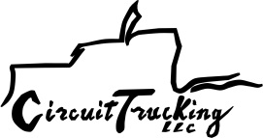
Driver Qualifications
Below is a list of the driver qualifications required by the FMCSA
Drivers must hold valid CDL, if operating interstate, intrastate or foreign commerce and drive CMV. Drivers that don’t drive safely are disqualified.
Be 21 years of age or older
Speak English well enough to converse, read traffic signs, respond to official questions and make understandable entries on reports and logs.
Able to drive vehicle safely
Be in good health and able to perform driver duties
Possess valid medical certificate
Provide potential employer with list of all violations in past 12 months or statement if none
Qualified to drive CMV
Pass driver’s road test
Know how to safely load and properly block, brace and secure the cargo
CDL holders are considered to have automatically consented to alcohol testing by any state/jurisdiction
Driver cannot drive if fatigued or ill to the point of being unsafe while operating CMV
Cannot drive under the influence of Schedule 1, substance, amphetamine, narcotics (derivatives), any other substance inhibiting driving
Cannot consume alcohol 4 hours prior to going on duty, while on duty or driving
Cannot possess alcohol while on duty or driving unless shipping (manifested)
Cannot drive unless shipment is secured properly and safe

